Step 1:

Write the code of which you will need more than one time.

Step 2:

Go to flutter outline from the right bar.

Step 3:

Click on the widget of which you want to convert.

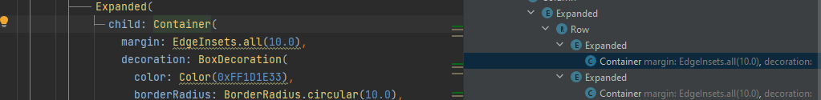

Step 4:

Right click the code from flutter outline and select extract widget.

Step 5: give name to that widget.

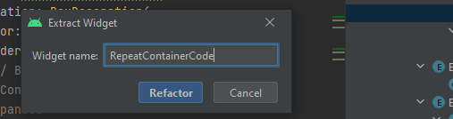

And you are done. Now copy and paste new code wherever you like.

To use arguments in the code to change color for every new widget using this code make following changings.

class RepeatContainerCode extends StatelessWidget {  
 RepeatContainerCode({required this.colors});  
 final Color colors;  
  
 @override  
 Widget build(BuildContext context) {  
 return Container(  
 margin: EdgeInsets.all(10.0),  
 decoration: BoxDecoration(  
 color: colors,  
 borderRadius: BorderRadius.circular(10.0),  
 ),  
 );  
 }  
}